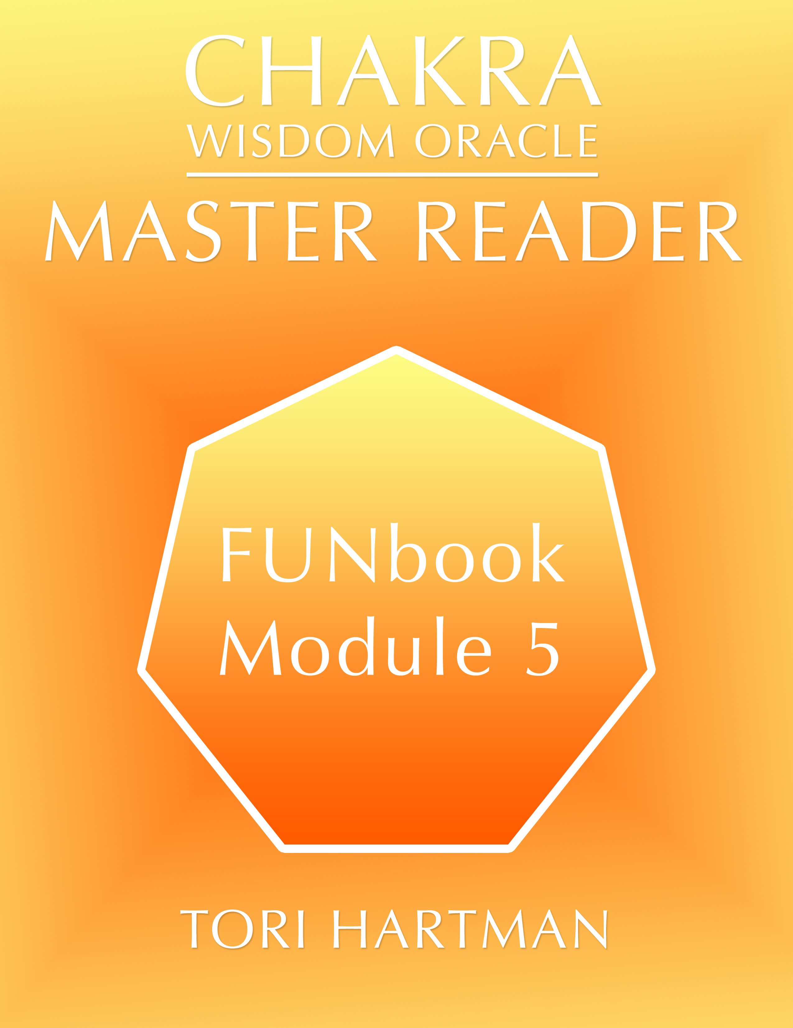
This weeks reading:

After asking permission to read the person, even before, begin tapping into their energy and observe what is going on with you. Take a full minute (timed) to become aware of what is going on internally before starting.
Share this with your client. What did you notice coming forward?

CLIENT: Allow the reader to do their job. Be with them. Be sincere in your quest to live into your master vision.
Module 5 FUNBook

READER: The Objective is for you to use what you learned in the Module 5 Video and MP3.

What tools are in your toolkit?

NEUTRAL OBSERVER: what did you experience? Could you notice the synchronicity? Was there a supportive feeling created?
If not, what if any, missed opportunities were there?

WHAT tools were you reminded of to use, if any?

Certification Process:
As a team, pick one chakra reading for EACH chakra. Which one works for Red or the first aspect. Put up your simple first chakra/aspect reading. Pick the one that works for you.
Post YOUR Choice on Facebook.



